TABLE OF CONTENTS
1 Practic 1: Adding core data to Incident Tracking project: 2
1.1 Adding core data frame work: 2
1.2 Create Data Model (Right Click on “Incident Tracking” Folder –> New File) 3
1.3 Initializing the Managed Object Context 6
2 Practice 2: Using core data to store the incident object 7
2.1 Populate Table view with data 7
2.1.1 Editing MasterViewController.h as below 7
2.1.2 Editing MasterViewController.m as below 7
2.2 Adding new incident 10
2.2.1 Edit AddIncidentViewController.h 10
2.2.2 Edit AddIncidentViewController.m 10
2.2.3 Editing DetailViewController.m 11

Practic 1: Adding core data to Incident Tracking project:

Adding core data frame work:
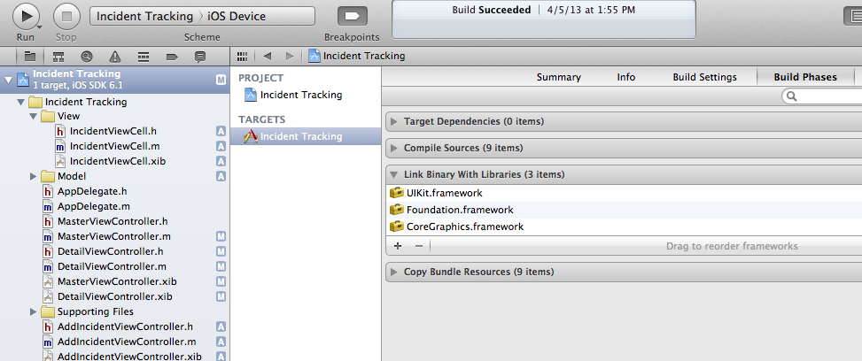

1
3

2

4

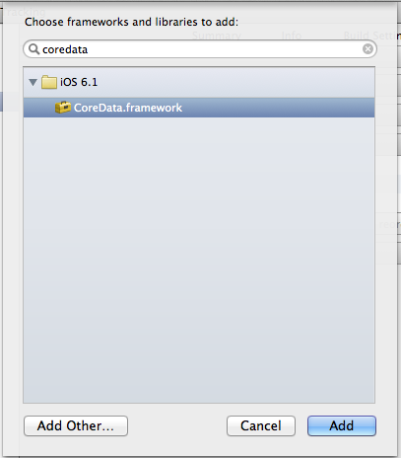
5

6

Create Data Model (Right Click on “Incident Tracking” Folder –> New File)
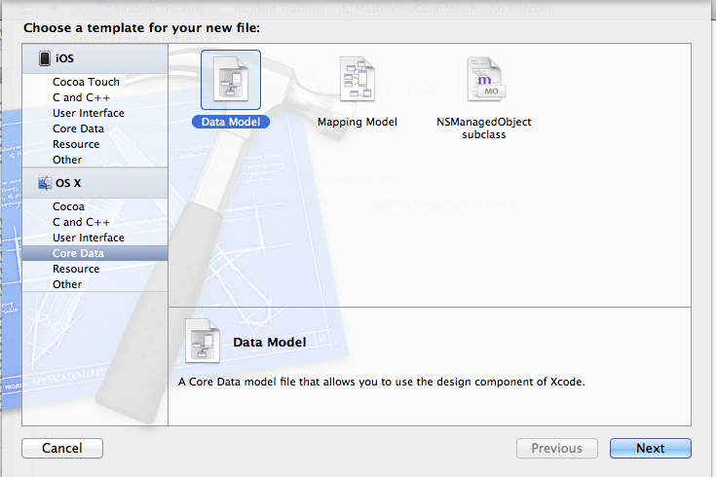
Choose Data Model template and Click Next button
1
2

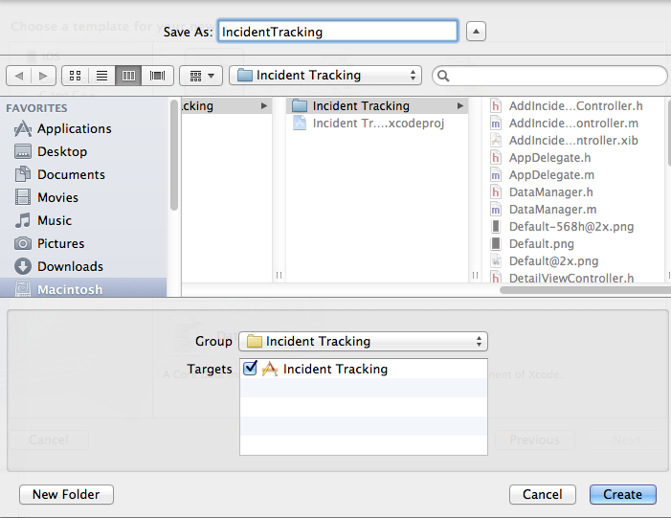
3

4

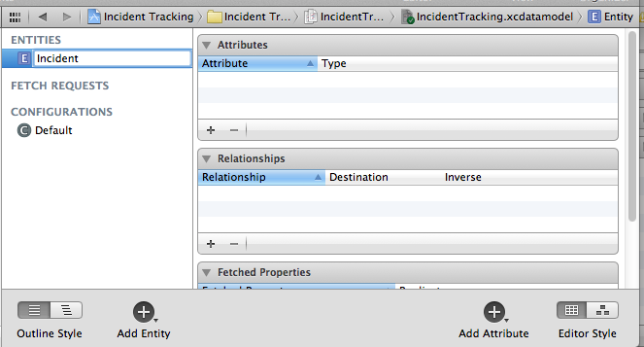
Adding Entity
1
2

Adding Attributes
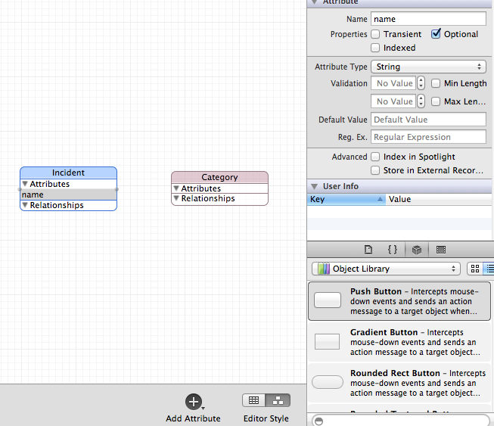
2

3

1

Adding Relationship
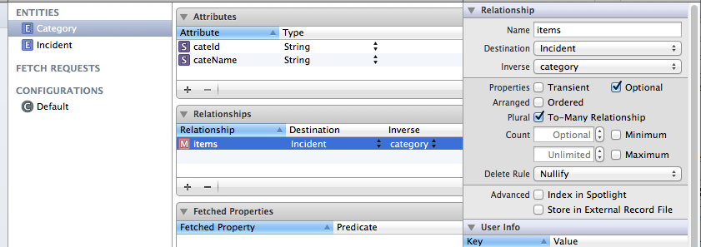
1
3

4
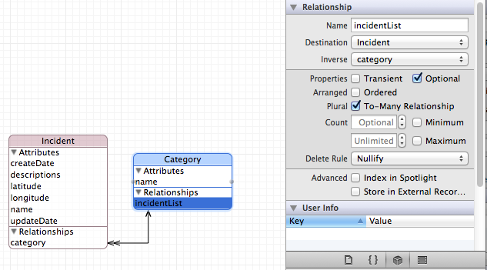
2

Initializing the Managed Object Context
Editing AppDelegate.h as below
#import <UIKit/UIKit.h>

@interface AppDelegate : UIResponder <UIApplicationDelegate>

@property (strong, nonatomic) UIWindow *window;

@property (readonly, strong, nonatomic) NSManagedObjectContext *managedObjectContext;
@property (readonly, strong, nonatomic) NSManagedObjectModel *managedObjectModel;
@property (readonly, strong, nonatomic) NSPersistentStoreCoordinator *persistentStoreCoordinator;
- (NSURL *)applicationDocumentsDirectory;

Editing AppDelegate.m as below
- (NSManagedObjectContext *)managedObjectContext
{
if (_managedObjectContext != nil) {
return _managedObjectContext;
}

NSPersistentStoreCoordinator *coordinator = [self persistentStoreCoordinator];
if (coordinator != nil) {
_managedObjectContext = [[NSManagedObjectContext alloc] init];
[_managedObjectContext setPersistentStoreCoordinator:coordinator];
}
return _managedObjectContext;
}

// Returns the managed object model for the application.
// If the model doesn't already exist, it is created from the application's model.
- (NSManagedObjectModel *)managedObjectModel
{
if (_managedObjectModel != nil) {
return _managedObjectModel;
}
NSURL *modelURL = [[NSBundle mainBundle] URLForResource:@"IncidentTracking" withExtension:@"momd"];
_managedObjectModel = [[NSManagedObjectModel alloc] initWithContentsOfURL:modelURL];
return _managedObjectModel;
}

// Returns the persistent store coordinator for the application.
// If the coordinator doesn't already exist, it is created and the application's store added to it.
- (NSPersistentStoreCoordinator *)persistentStoreCoordinator
{
if (_persistentStoreCoordinator != nil) {
return _persistentStoreCoordinator;
}

NSURL *storeURL = [[self applicationDocumentsDirectory] URLByAppendingPathComponent:@"IncidentTracking.sqlite"];

NSError *error = nil;
_persistentStoreCoordinator = [[NSPersistentStoreCoordinator alloc] initWithManagedObjectModel:[self managedObjectModel]];
if (![_persistentStoreCoordinator addPersistentStoreWithType:NSSQLiteStoreType configuration:nil URL:storeURL options:nil error:&error]) {

NSLog(@"Unresolved error %@, %@", error, [error userInfo]);
abort();
}

return _persistentStoreCoordinator;
}

#pragma mark - Application's Documents directory

// Returns the URL to the application's Documents directory.
- (NSURL *)applicationDocumentsDirectory
{
return [[[NSFileManager defaultManager] URLsForDirectory:NSDocumentDirectory inDomains:NSUserDomainMask] lastObject];
}

Practice 2: Using core data to store the incident object

Populate Table view with data

Editing MasterViewController.h as below

#import <UIKit/UIKit.h>

@class DetailViewController;

@interface MasterViewController : UITableViewController

@property (strong, nonatomic) DetailViewController *detailViewController;

@property (strong, nonatomic) NSFetchedResultsController *fetchedResultsController;
@property (strong, nonatomic) NSManagedObjectContext *managedObjectContext;

Editing MasterViewController.m as below

#pragma mark - Table View

/////////////////////////////////////////Edit/////////////////////////////////////////////////
- (NSInteger)numberOfSectionsInTableView:(UITableView *)tableView
{
return 1;
}
/////////////////////////////////////////Edit/////////////////////////////////////////////////

- (NSInteger)tableView:(UITableView *)tableView numberOfRowsInSection:(NSInteger)section
{
return [[self.fetchedResultsController fetchedObjects] count];
}

/////////////////////////////////////////Edit/////////////////////////////////////////////////

// Customize the appearance of table view cells.
- (UITableViewCell *)tableView:(UITableView *)tableView cellForRowAtIndexPath:(NSIndexPath *)indexPath
{
static NSString *CellIdentifier = @"Cell";

IncidentViewCell *cell = [tableView dequeueReusableCellWithIdentifier:CellIdentifier];
if (cell == nil) {
//cell = [[IncidentCell alloc] initWithStyle:UITableViewCellStyleDefault reuseIdentifier:CellIdentifier];
NSArray* views = [[NSBundle mainBundle] loadNibNamed:@"IncidentViewCell" owner:nil options:nil];

for (UIView *view in views) {
if([view isKindOfClass:[UITableViewCell class]])
{
cell = (IncidentViewCell*)view;
}
}
}

[self configureCell:cell atIndexPath:indexPath];
return cell;
}

/////////////////////////////////////////Edit/////////////////////////////////////////////////

- (void)tableView:(UITableView *)tableView didSelectRowAtIndexPath:(NSIndexPath *)indexPath
{
Incident *object = [self.fetchedResultsController objectAtIndexPath:indexPath];
self.detailViewController.detailItem = object;
}

/////////////////////////////////////////////////////////////////// Add ////////////////////////////////////////////////////////////////////////////////
- (void)configureCell:(UITableViewCell *)cell atIndexPath:(NSIndexPath *)indexPath
{
NSManagedObject *object = [self.fetchedResultsController objectAtIndexPath:indexPath];
Incident *incident = (Incident*)object;

IncidentViewCell *iCell = (IncidentViewCell*)cell;
iCell.nameLbl.text = incident.name;
if (incident.category) {
iCell.categoryLbl.text = incident.category.name;
}

NSString *dateString = [NSDateFormatter localizedStringFromDate:incident.createDate
dateStyle:NSDateFormatterShortStyle
timeStyle:NSDateFormatterNoStyle];
iCell.createDateLbl.text = dateString;
}

//////////////////////////////////////////////////////// Add //////////////////////////////////////////////////////////////
- (NSFetchedResultsController *)fetchedResultsController
{
if (_fetchedResultsController != nil) {
return _fetchedResultsController;
}

[self queryAllIncident];

return _fetchedResultsController;
}
- (void)queryAllIncident{
self.title = NSLocalizedString(@"Incident List", @"Incident List");
NSFetchRequest *fetchRequest = [[NSFetchRequest alloc] init];
// Edit the entity name as appropriate.
NSEntityDescription *entity = [NSEntityDescription entityForName:@"Incident" inManagedObjectContext:self.managedObjectContext];
[fetchRequest setEntity:entity];

// Set the batch size to a suitable number.
[fetchRequest setFetchBatchSize:20];

// Edit the sort key as appropriate.

NSSortDescriptor *sortDescriptor = [[NSSortDescriptor alloc] initWithKey:@"name" ascending:NO];
NSArray *sortDescriptors = @[sortDescriptor];
[fetchRequest setSortDescriptors:sortDescriptors];

// Edit the section name key path and cache name if appropriate.
// nil for section name key path means "no sections".
NSFetchedResultsController *aFetchedResultsController = [[NSFetchedResultsController alloc] initWithFetchRequest:fetchRequest managedObjectContext:self.managedObjectContext sectionNameKeyPath: nil cacheName:nil];
aFetchedResultsController.delegate = self;
self.fetchedResultsController = aFetchedResultsController;

NSError *error = nil;
if (![self.fetchedResultsController performFetch:&error]) {
NSLog(@"Unresolved error %@, %@", error, [error userInfo]);
abort();
}
}

//////////////////////////////////////////////////Add//////////////////////////////////////////////////////////////////
#pragma mark - Fetch result delegate
- (void)controllerWillChangeContent:(NSFetchedResultsController *)controller
{
[self.tableView beginUpdates];
}

- (void)controller:(NSFetchedResultsController *)controller didChangeObject:(id)anObject
atIndexPath:(NSIndexPath *)indexPath forChangeType:(NSFetchedResultsChangeType)type
newIndexPath:(NSIndexPath *)newIndexPath
{
UITableView *tableView = self.tableView;
switch(type) {
case NSFetchedResultsChangeInsert:
[tableView insertRowsAtIndexPaths:@[newIndexPath] withRowAnimation:UITableViewRowAnimationFade];
break;

case NSFetchedResultsChangeDelete:
[tableView deleteRowsAtIndexPaths:@[indexPath] withRowAnimation:UITableViewRowAnimationFade];
break;

case NSFetchedResultsChangeUpdate:
[self configureCell:[tableView cellForRowAtIndexPath:indexPath] atIndexPath:indexPath];

break;

case NSFetchedResultsChangeMove:
[tableView deleteRowsAtIndexPaths:@[indexPath] withRowAnimation:UITableViewRowAnimationFade];
[tableView insertRowsAtIndexPaths:@[newIndexPath] withRowAnimation:UITableViewRowAnimationFade];
break;
}
}

- (void)controllerDidChangeContent:(NSFetchedResultsController *)controller
{
[self.tableView endUpdates];
}

Adding new incident

Edit AddIncidentViewController.h

//////////////////////Edit/////////////////////////////////////////////////
#import <UIKit/UIKit.h>

@interface AddIncidentViewController : UIViewController

@property (weak, nonatomic) IBOutlet UITextField *nameTxtField;

@property (weak, nonatomic) IBOutlet UITextField *categoryTxtField;

@property (weak, nonatomic) IBOutlet UITextView *descriptionTxtView;

@property (strong, nonatomic) id delegate;

Edit AddIncidentViewController.m
//////////////////////Edit /////////////////////////////////////////////////
#import "AddIncidentViewController.h"

#import "DataManager.h"

#import "Incident.h"

#import "Category.h"

#import "AppDelegate.h"

@interface AddIncidentViewController ()

////////////////////// Edit /////////////////////////////////////////////////
- (void) doneBtnTouched
{

AppDelegate *del = [[UIApplication sharedApplication] delegate];
Incident * inc = (Incident *)[NSEntityDescription insertNewObjectForEntityForName:@"Incident" inManagedObjectContext:del.managedObjectContext];

inc.name = _nameTxtField.text;
inc.descriptions = _descriptionTxtView.text;
inc.category = [self category:_categoryTxtField.text];
inc.createDate = [NSDate date];

[_delegate performSelector:@selector(setDetailItem:) withObject:inc];

NSError *error;
[del.managedObjectContext save:&error];

[self.navigationController popViewControllerAnimated:YES];
}
////////////////////// Add /////////////////////////////////////////////////

- (Category*) category:(NSString *)name
{
Category * category;
AppDelegate *del = [[UIApplication sharedApplication] delegate];
NSFetchRequest *request = [[NSFetchRequest alloc] init];
NSManagedObjectContext *moc = del.managedObjectContext;
NSEntityDescription *entity = [NSEntityDescription entityForName:@"Category" inManagedObjectContext:moc];

[request setEntity:entity];

[request setPredicate:[NSPredicate predicateWithFormat:@"name = %@", name]];

NSError *error = nil;
NSArray *results = [moc executeFetchRequest:request error:&error];
if (results && results.count > 0) {
category = [results objectAtIndex:0];
} else {//Add new category
Category * cate = (Category *)[NSEntityDescription insertNewObjectForEntityForName:@"Category" inManagedObjectContext:del.managedObjectContext];
cate.name = name;
category = cate;
}

return category;
}

Editing DetailViewController.m
#import "DetailViewController.h"

#import "Incident.h"

#import "Category.h"

#import "AddIncidentViewController.h"

- (void)configureView
{
// Update the user interface for the detail item.

if (self.detailItem) {
self.nameLbl.text = [self.detailItem name];
self.categoryLbl.text = self.detailItem.category.name;
self.descriptionTxtView.text = [self.detailItem descriptions];
}
}

